**Create a react application to display the output as show in the screenshot.**

Watch: <https://www.youtube.com/watch?v=_YQ_F5T0_f8>

1. The above given output contains four function components, (locate them in the given snippets)
   1. **Home**

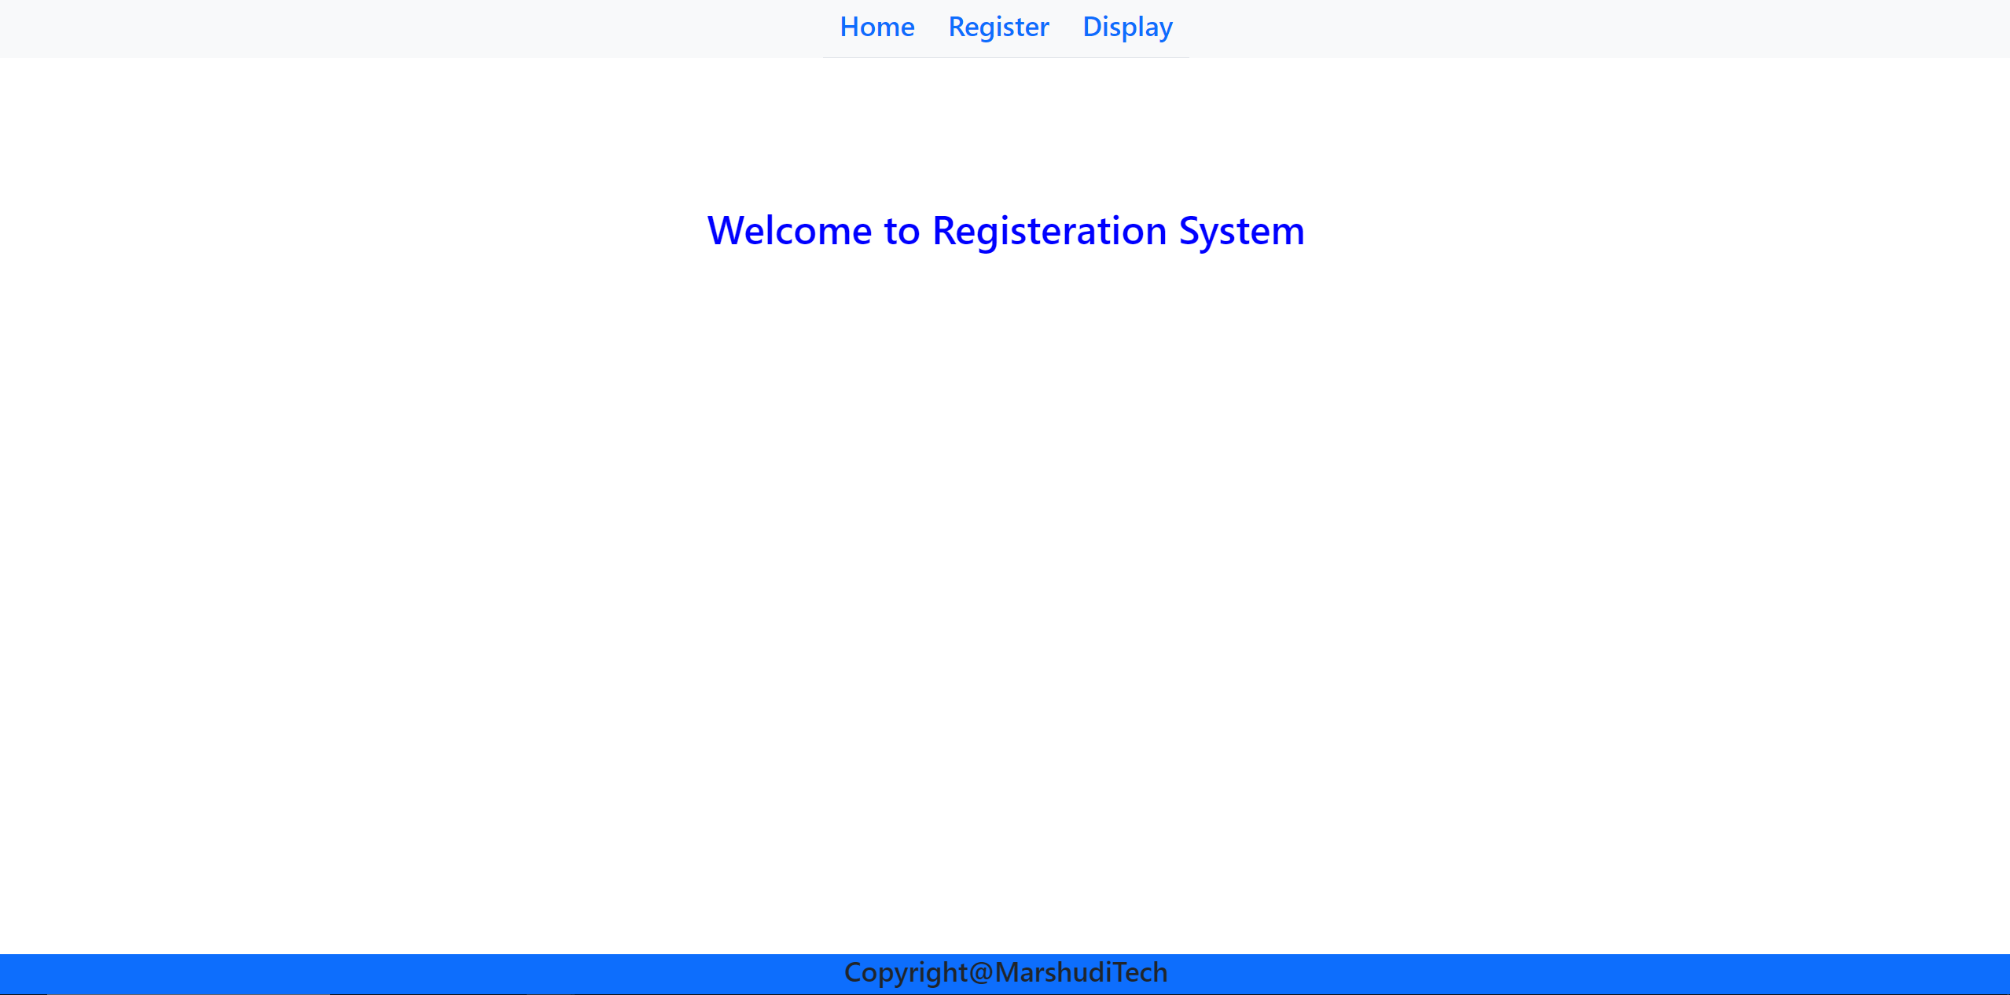

* 1. **Register**

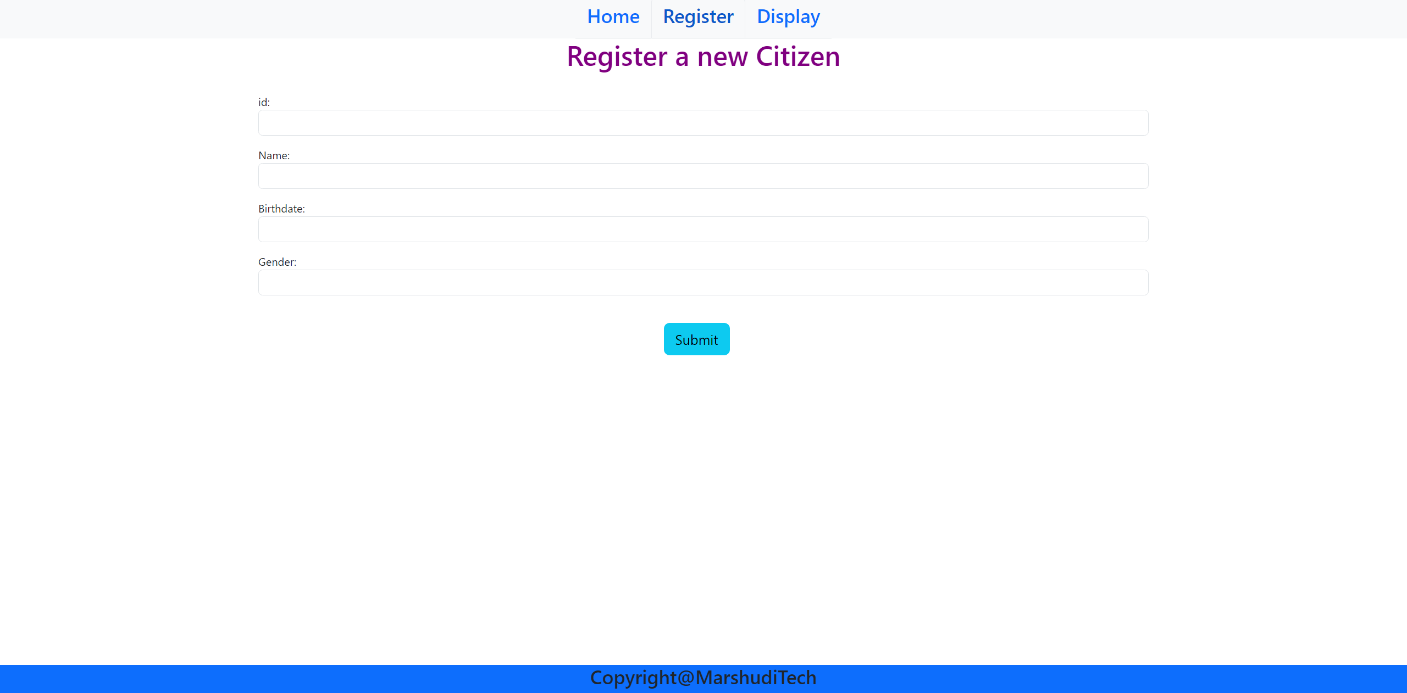

* 1. **Display**

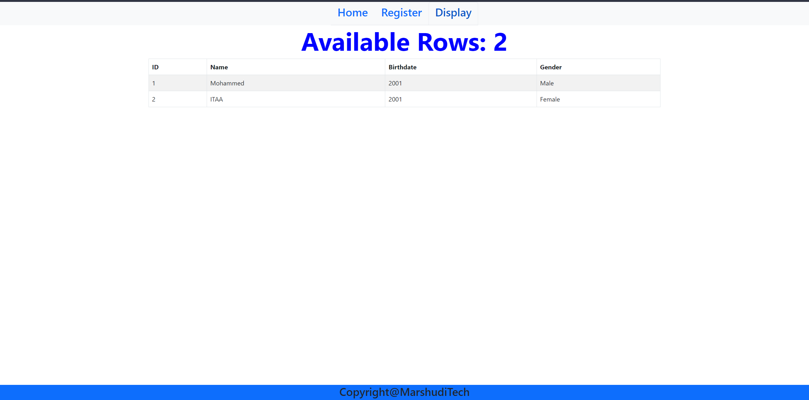

* 1. **Footer**
     + Copyright@**YourStudentID**

1. All components must be present in **App.js**

Create a folder with your ID, place the **src** and **public** and **server** folders from your project, compress and upload it on the e-Exam link

**Note:** You can use the given code snippets in appropriate places along with the required modifications to show the desired output.

**NOTE: They my give you this on final and may not!!**

**Install the required packages from the following.**

**Client:**

* bootstrap
* axios
* react-router-dom@lates

**Server:**

* express
* mongoose
* cors
* mongodb

**Client**

* Apply the following Style of each components according to the output giving above

Code Snippets APP

import "bootstrap/dist/css/bootstrap.min.css";

import "bootstrap/dist/js/bootstrap.bundle.min";

import {BrowserRouter, Routes, Route,Link} from "react-router-dom";

**Server**

* Create a table containing the following:
  + ID
  + Name
  + Birthdate
  + Gender